Task 1: Configure VPC Peering Across Regions

Objective

Allow communication between two VPCs located in different AWS regions.
Prerequisites
- Two AWS Regions
- Two VPCs
- Non-overlapping CIDR blocks

Route tables Outcome
- Cross-region communication established.
Example
- Region 1: us-east-1
- Region 2: us-west-1
Steps
- Create another VPC in us-west-1.
  - CIDR: 192.168.0.0/16
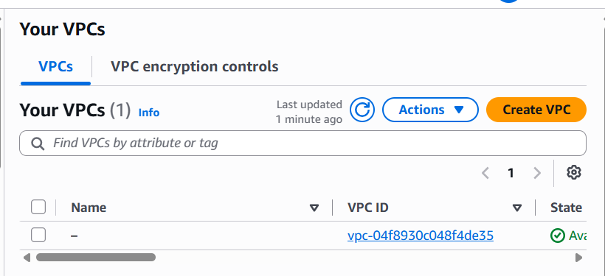
  - 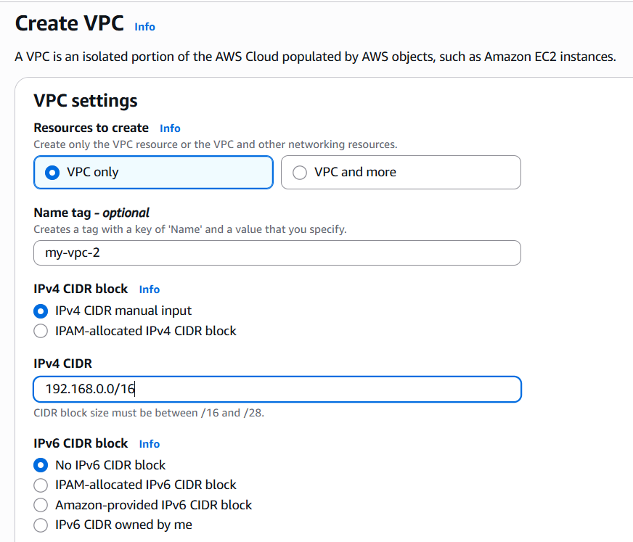
After creating:
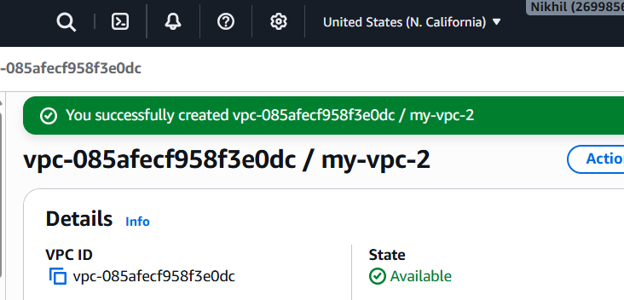
- Go to VPC → Peering Connections.
- Click Create Peering Connection.
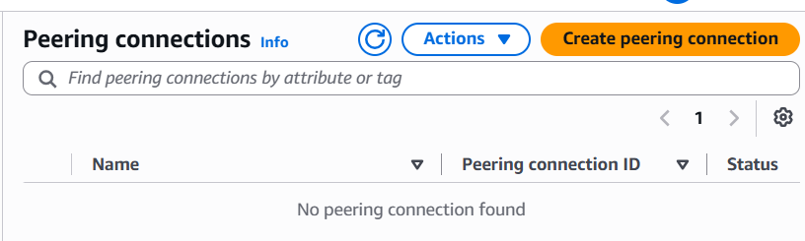
Configure:
- Requester VPC → VPC in us-east-1
- Accepter VPC → VPC in us-west-1
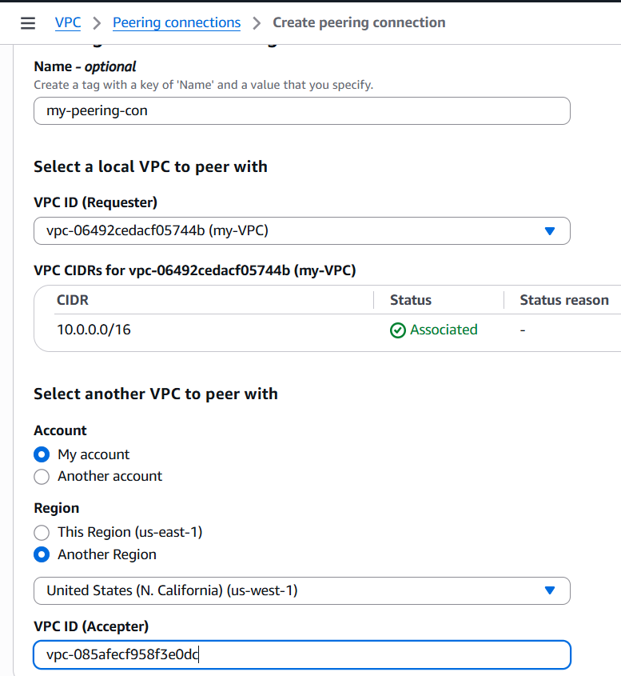
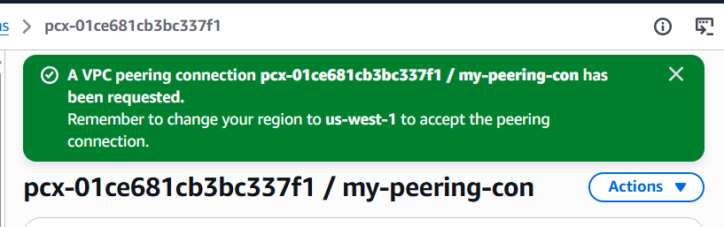
- Switch to us-west-2.
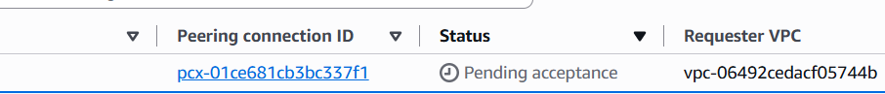
- Accept the peering request.
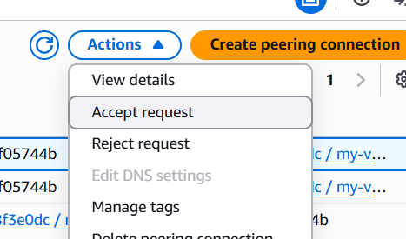
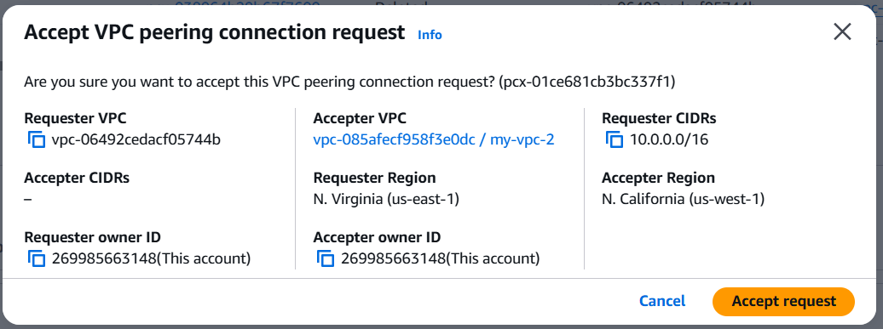
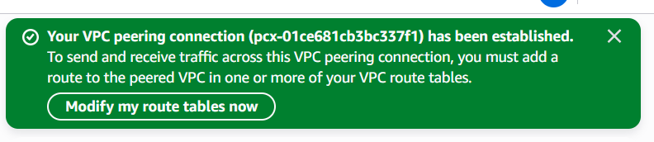
Status should be active
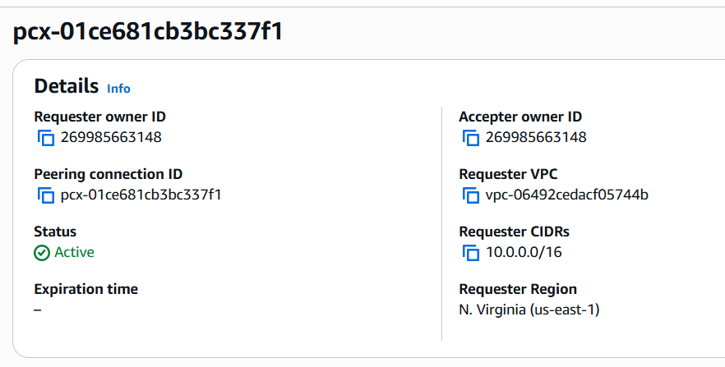
- Update both VPCs' route tables.
Example:
VPC 1 Route Table
Destination | Target
192.168.0.0/16 | Peering Connection
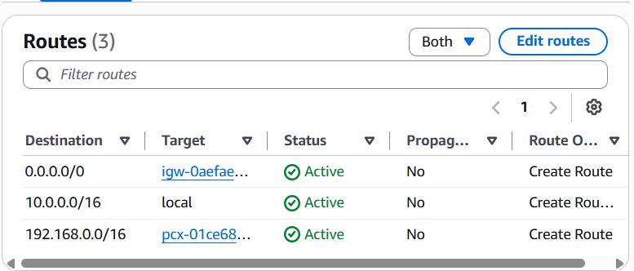
VPC 2 Route Table
Destination | Target
10.0.0.0/16 | Peering Connection

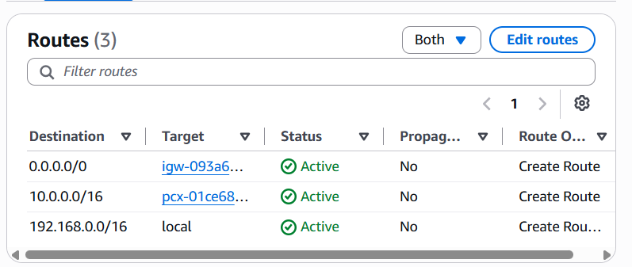
7. Check the status of peering connection in both regions
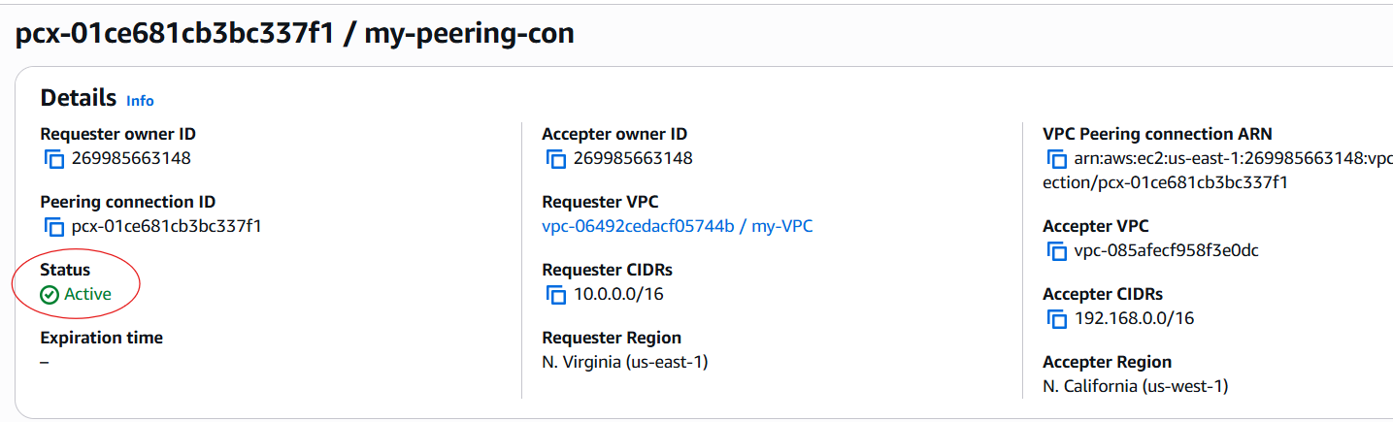

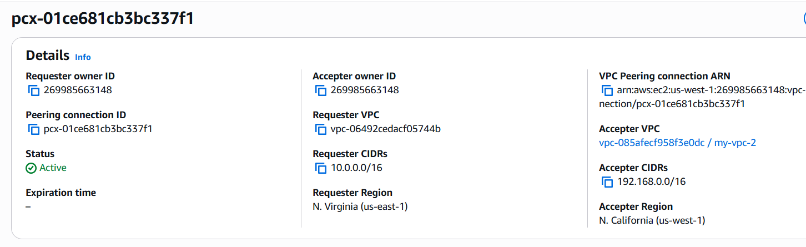

Task 2: Purchase a Domain from GoDaddy

Objective
Purchase a public domain.

Prerequisites
- GoDaddy account
- Payment method

Steps
Login
GoDaddy
Search
nikhildevops
Purchase
1 year
Disable
Domain Privacy
(Optional)

Outcome
You own a public domain.
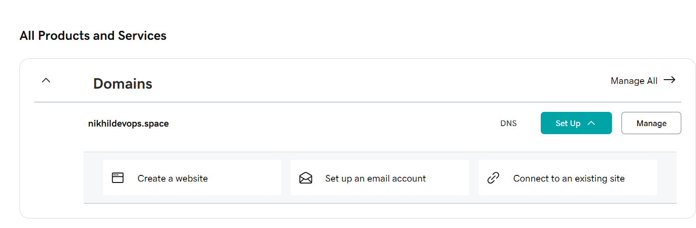

Real-Time Use Case
company.com
will point to AWS-hosted applications.

Task 3: Deploy Static Website in S3

Objective
Host a website using Amazon S3.

Prerequisites
- HTML files
- S3 bucket

Implementation
Create Bucket
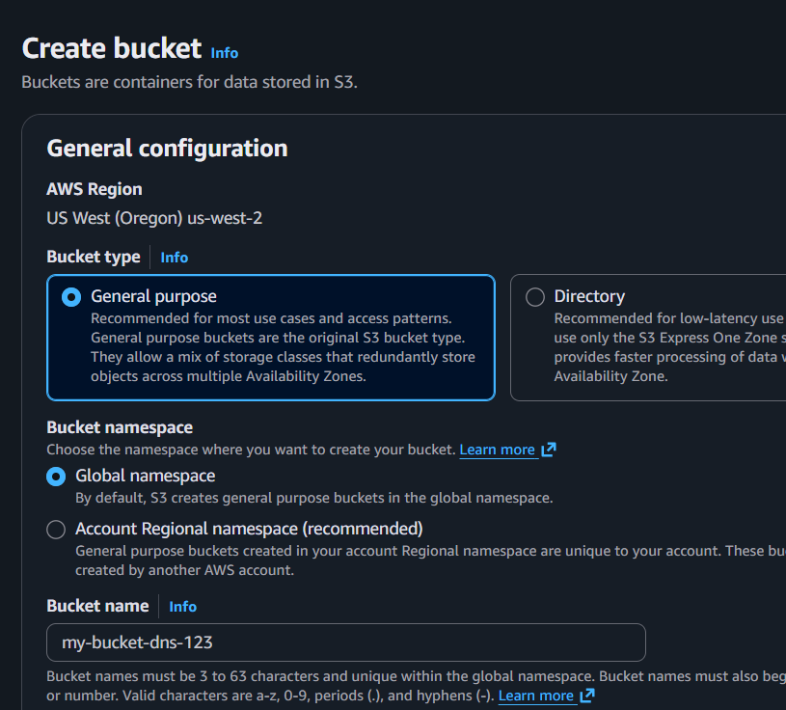
Disable
Block Public Access
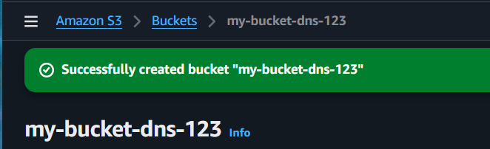
Enable
Static Website Hosting
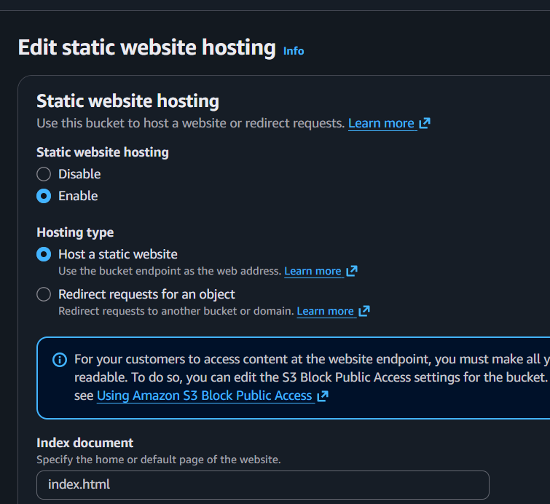
Upload
index.html
error.html
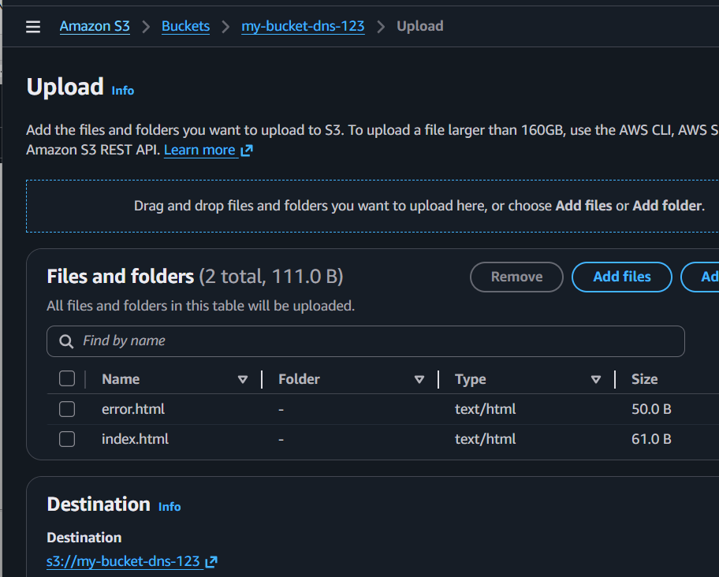
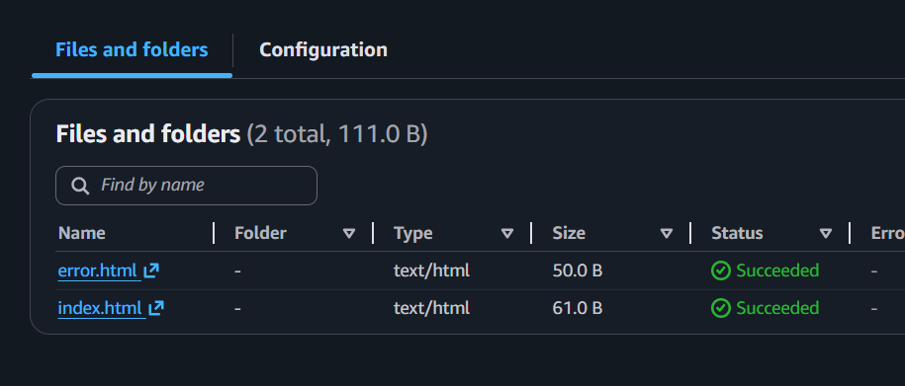
give Bucket Policy as
{
"Version":"2012-10-17",
"Statement":[
{
"Sid":"PublicRead",
"Effect":"Allow",
"Principal":"*",
"Action":"s3:GetObject",
"Resource":"arn:aws:s3:::my-bucket-dns-123/*"
}
]
}
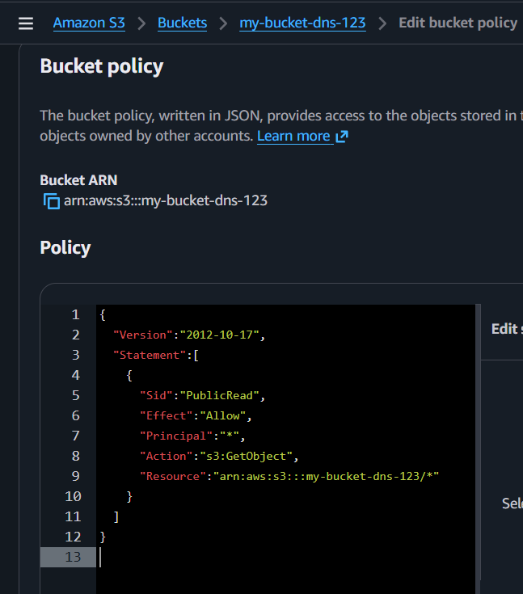

Test
Open
Website Endpoint
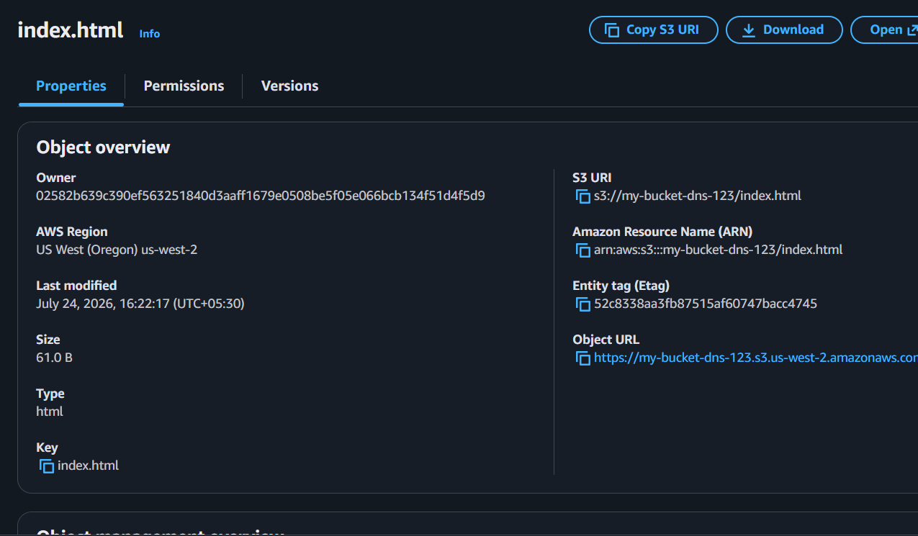

Outcome
Website opens from S3 endpoint.
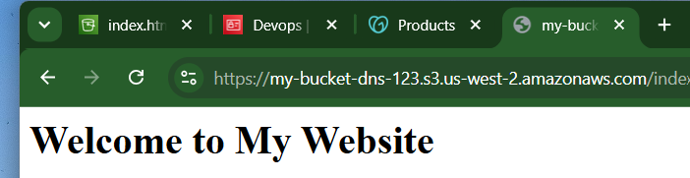

Real-Time Use Case
Hosting
- Company landing page
- Documentation
- Portfolio
- Resume website

Task 4: Create CloudFront CDN and Attach SSL

Objective
Serve website globally with HTTPS.

Prerequisites
- S3 Bucket
- ACM Certificate

Part 1 – Request an SSL Certificate
Important: CloudFront only works with ACM certificates created in the US East (N. Virginia) (us-east-1) region.

Step 1
Go to
AWS Console
→ Region
→ US East (N. Virginia)

Step 2
Search
Certificate Manager
Open AWS Certificate Manager (ACM).

Step 3
Click
Request Certificate
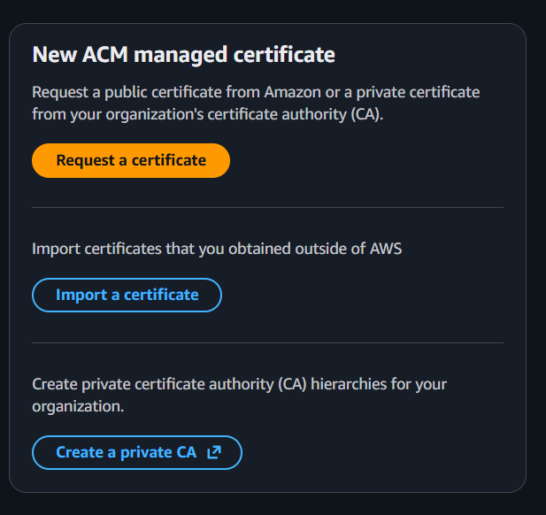

Step 4
Choose
Request a public certificate
Click
Next

Step 5
Enter domain names.
Example
example.com

Step 6
Validation method
Choose
DNS Validation
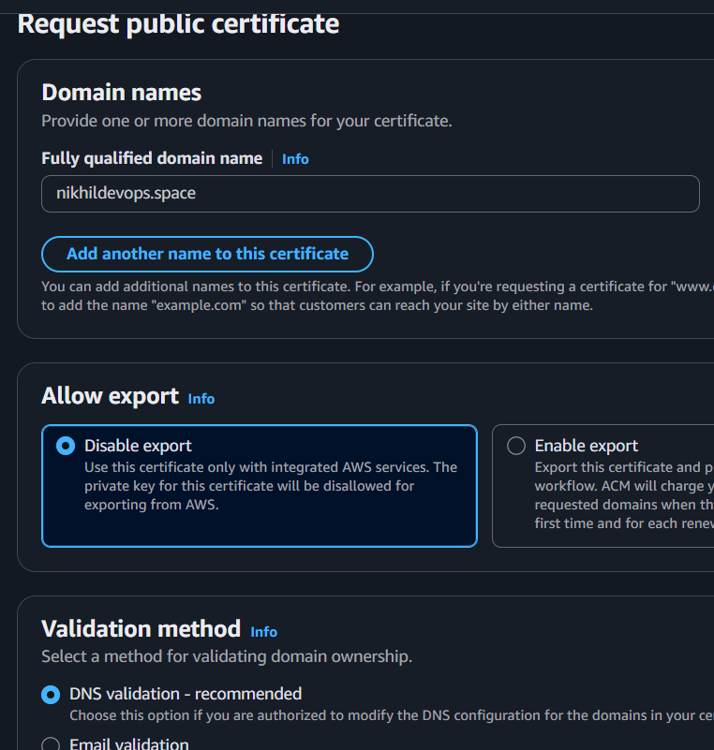
Click
Request
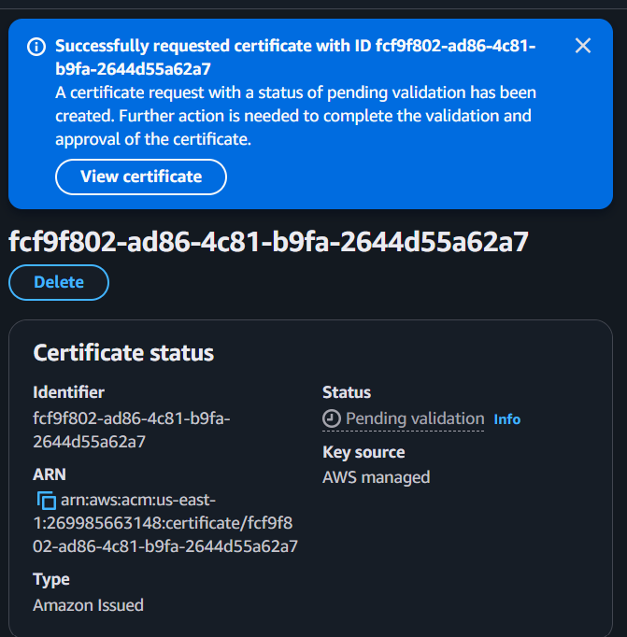

Part 2 – Validate Certificate
AWS provides one or more CNAME records.
Example
Type | Name | Value
CNAME | _abc123.example.com | _xyz.acm-validations.aws
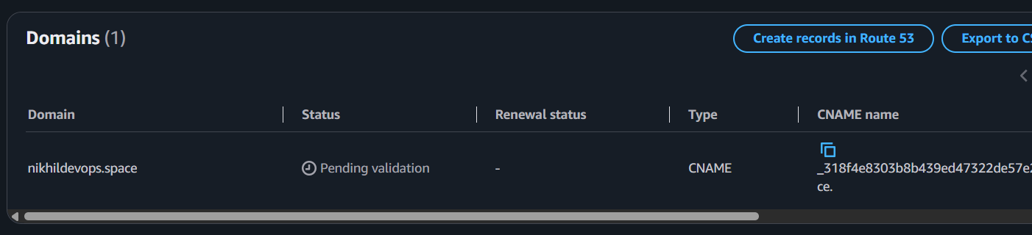
add cname and value in godaddy account under my products
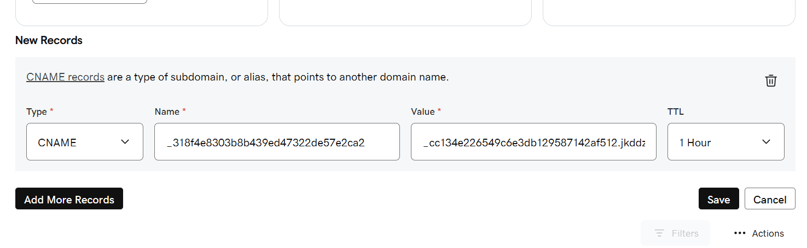
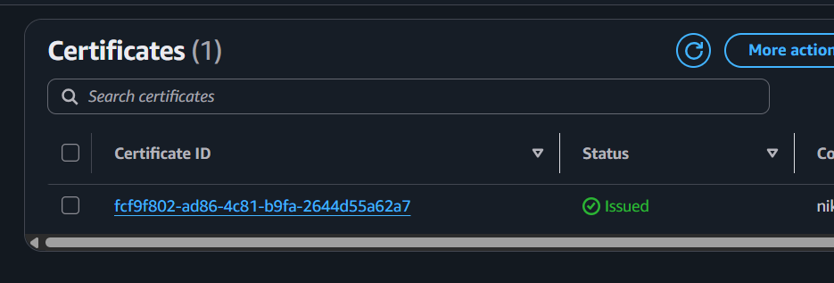

If Route 53 hosted zone already exists:
Click
Create records in Route53
Done.

If Route53 is not created yet:
Copy the CNAME values.
Later add them in GoDaddy DNS or Route53.
Wait 5–20 minutes for validation.
Once validated:
Status becomes
Issued

Part 3 – Create CloudFront Distribution
Go to
CloudFront
Click
Create Distribution
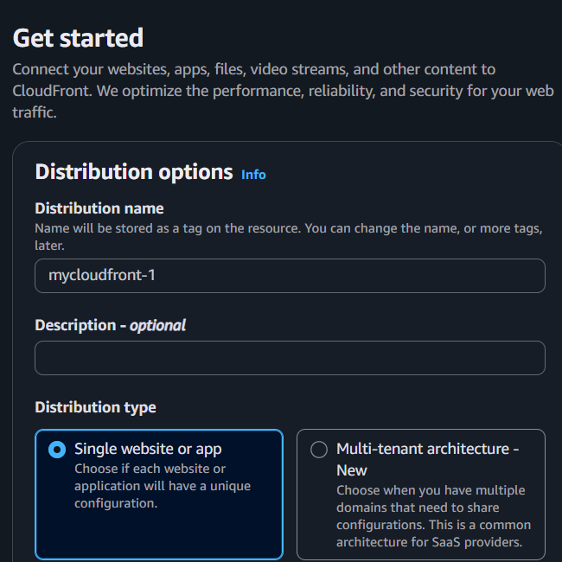

Origin Domain
Select your S3 bucket.
Example
my-static-site
Do not select the S3 website endpoint. Choose the bucket itself (recommended with Origin Access Control).
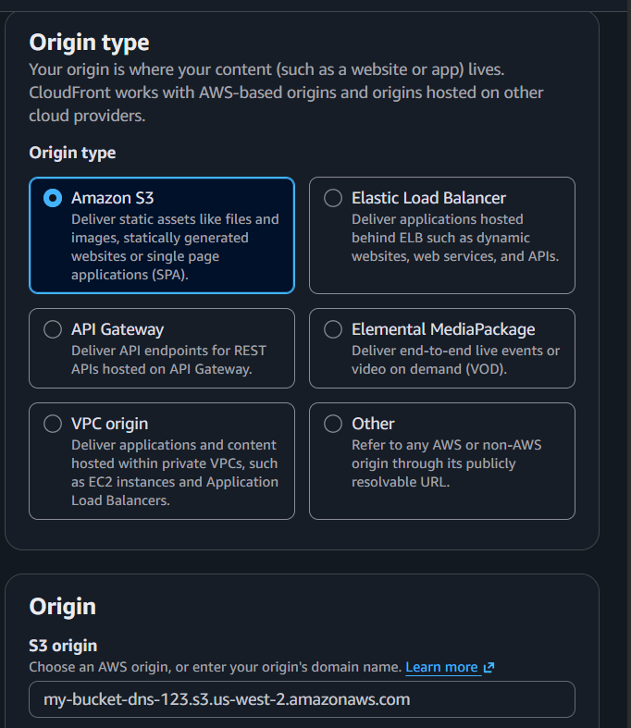

Origin Access
Select
Origin Access Control (OAC)
Click
Create new OAC
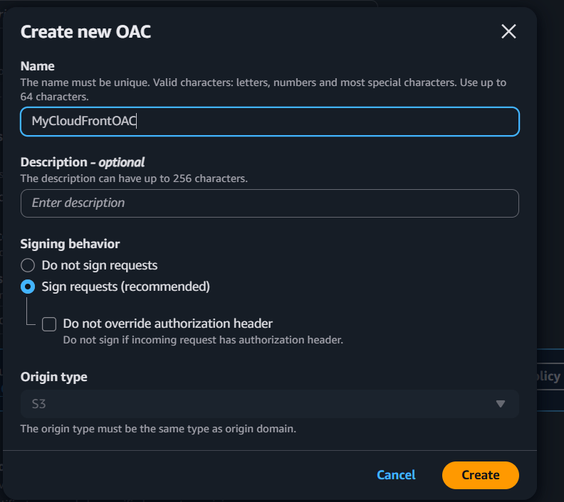
Then
Create Control Setting
Save.
Click
Update Bucket Policy
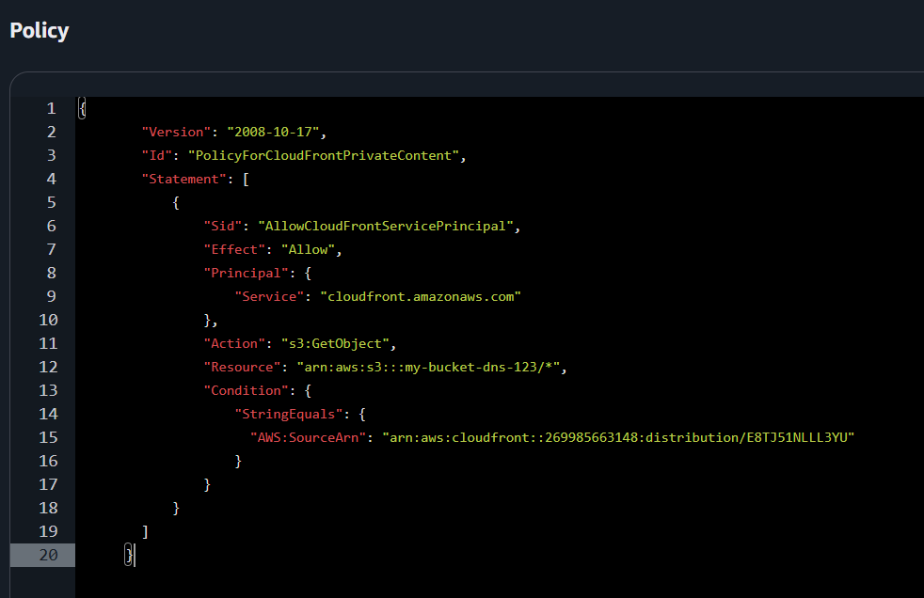
AWS automatically generates the required bucket policy.

Viewer Protocol Policy
Choose
Redirect HTTP to HTTPS
This automatically redirects users from HTTP to HTTPS.

Allowed HTTP Methods
Choose
GET, HEAD

Default Root Object
Enter
index.html
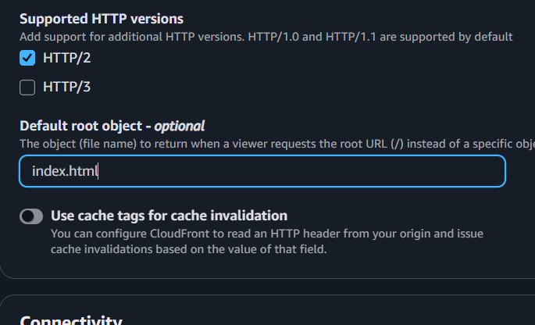

Alternate Domain Name (CNAME)
Add
example.com
or
www.example.com
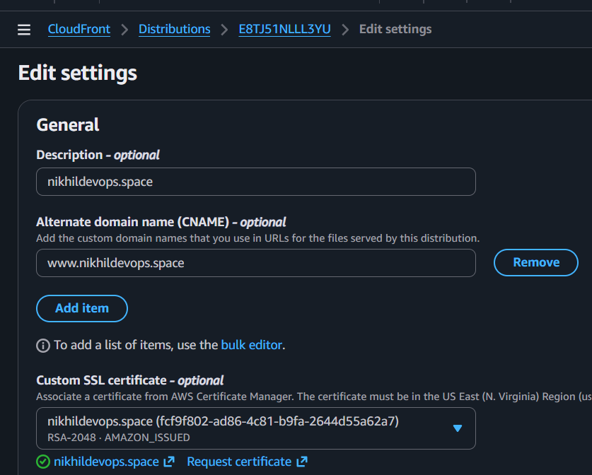

Custom SSL Certificate
Select
Custom SSL Certificate
Choose the ACM certificate you created earlier.

Security Policy
Leave the latest recommended TLS policy (default).

Price Class
For practice, you can select
Use all edge locations (Best Performance)
or choose a lower price class to reduce cost.

Click
Create Distribution
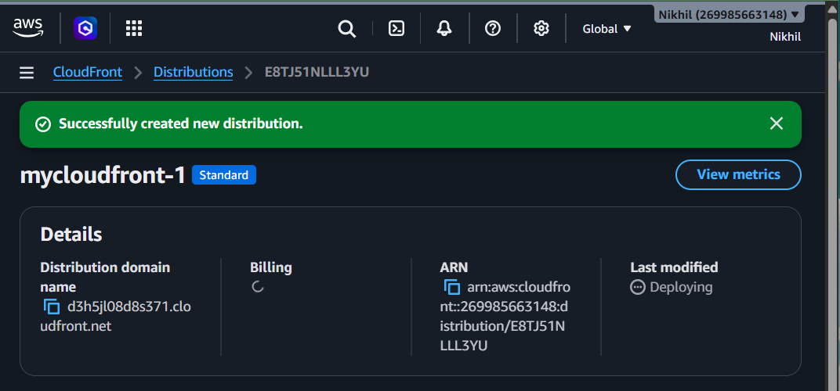

Wait for Deployment
CloudFront deployment usually takes:
10–20 minutes
Status changes from:
Deploying
to
Enabled
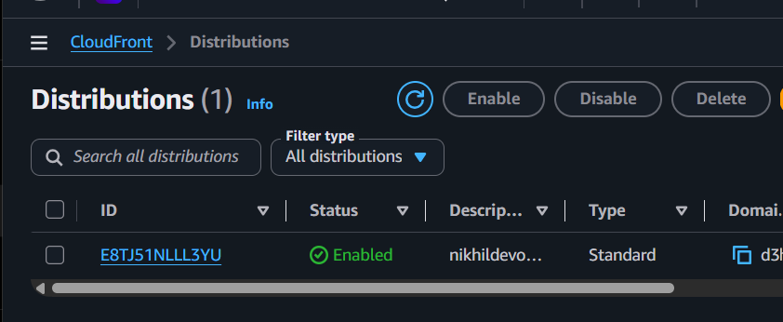

Test CloudFront
You'll receive a domain name like:
d123abcd1234.cloudfront.net
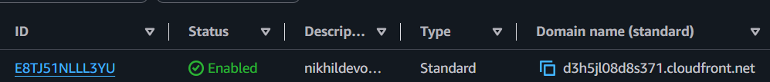
Open:
https://d123abcd1234.cloudfront.net
You should see your website.
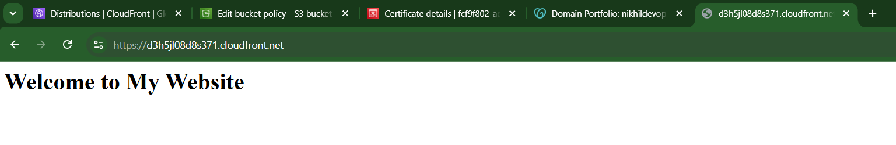

Real-Time Use Case
Suppose your S3 bucket is in Virginia.
A user from India accesses your website.
Without CloudFront:
India
│
Virginia S3
Higher latency.
With CloudFront:
India
│
Mumbai Edge Location
│
Virginia S3 (only if content is not cached)
The first request fetches content from S3; subsequent requests are served from the nearby edge location, improving performance.

Outcome
After completing this task:
- CloudFront distribution is created.
- S3 content is delivered through CloudFront.
- HTTPS is enabled with an ACM SSL certificate.
- HTTP requests automatically redirect to HTTPS.
- The CloudFront distribution provides a secure endpoint for your website.

Task 5: Create a Route 53 hosted zone and map the domain with the CDN.
Objective
Create a Route 53 Public Hosted Zone, move DNS management from GoDaddy to Route 53, and point our domain (nikhildevops.space) to your CloudFront distribution.

Architecture
Current:
Internet
│
GoDaddy DNS
│
CloudFront
│
S3 Bucket
After Task 5:
Internet
│
Route 53
│
CloudFront
│
S3 Bucket
GoDaddy will still be your domain registrar, but Route 53 will become your DNS provider.

Prerequisites
- ✅ Domain purchased from GoDaddy
- ✅ S3 static website deployed
- ✅ ACM certificate is Issued
- ✅ CloudFront distribution is Enabled/Deployed

Part 1: Create a Public Hosted Zone

Step 1
Open:
AWS Console → Route 53

Step 2
Click:
Hosted zones
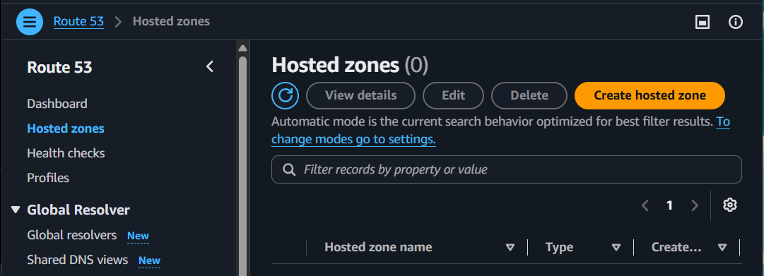

Step 3
Click:
Create hosted zone

Step 4
Fill in:
Field | Value
Domain name | nikhildevops.space
Type | Public Hosted Zone
Description | Optional
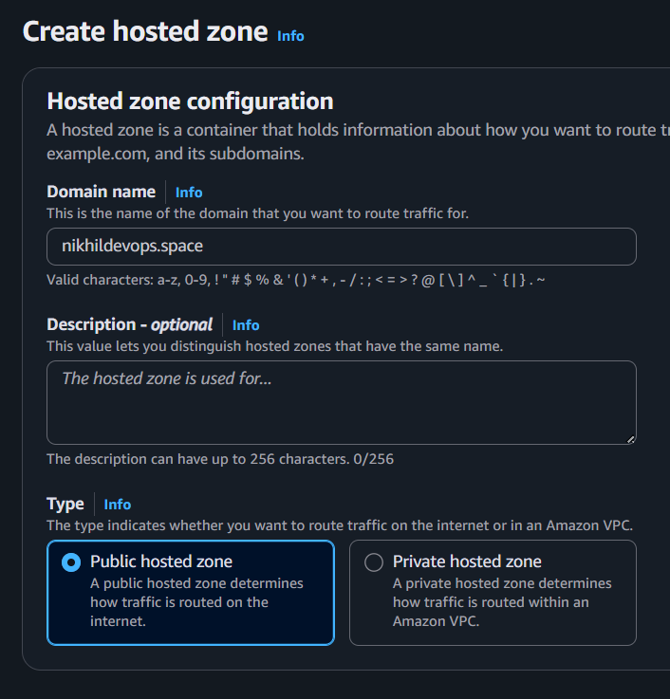
Click:
Create hosted zone

Outcome
AWS creates:
- NS Record
- SOA Record
The page looks like:
nikhildevops.space
NS
SOA
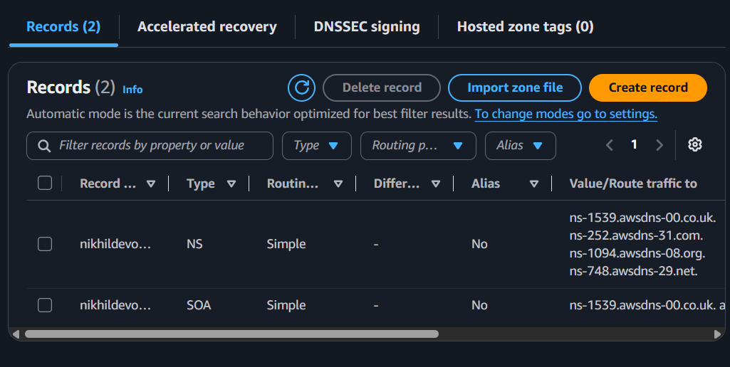

Part 2: Copy the Route 53 Name Servers
Open the NS record.
You'll see 4 nameservers similar to:
ns-120.awsdns-15.com.
ns-250.awsdns-32.net.
ns-900.awsdns-18.org.
ns-450.awsdns-67.co.uk.
Copy all four.
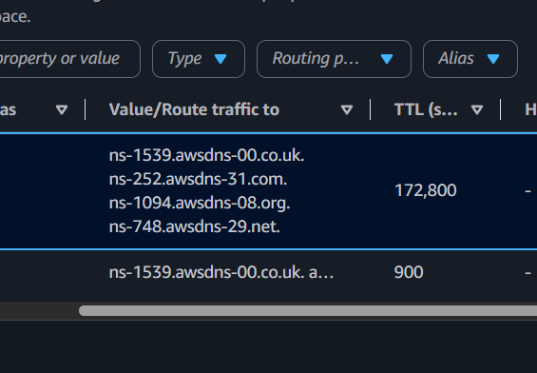

Part 3: Update GoDaddy Nameservers

Step 1
Login to GoDaddy.

Step 2
Go to
My Products
↓
Select your domain
↓
DNS

Step 3
Scroll to the bottom.
Find
Nameservers
Click
Change
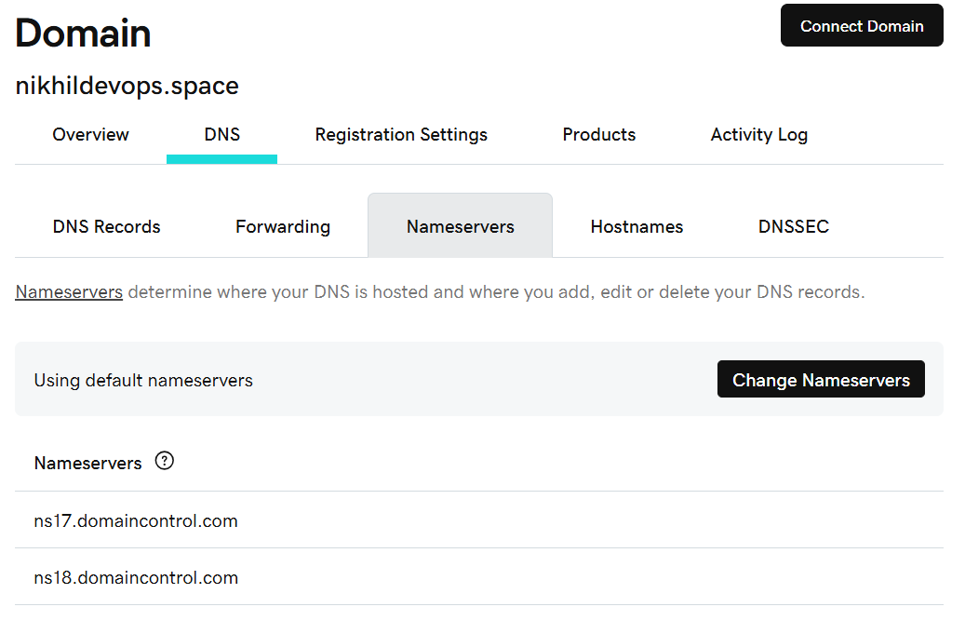

Step 4
Choose
I'll use my own nameservers
or
Custom Nameservers

Step 5
Delete the GoDaddy nameservers.
Paste the 4 Route 53 nameservers.
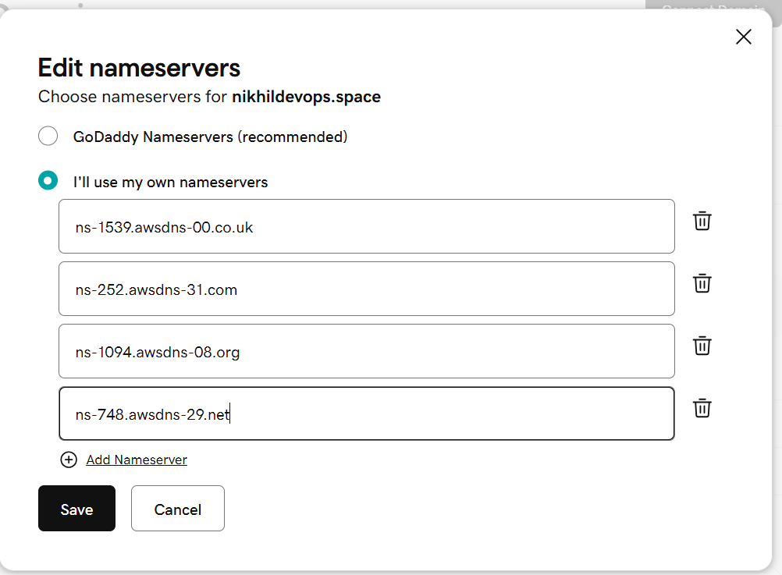
Click
Save

Wait for Propagation
Normally:
- 15 minutes–2 hours
- Sometimes up to 24–48 hours

During this time, Route 53 becomes the DNS authority.
There is one of way to confirm that the nameserver change has propagated.
Use the nslookup Command (Best)
Open Command Prompt (Windows) and run:
nslookup -type=NS nikhildevops.space
If the output shows:
ns-1539.awsdns-00.co.uk
ns-252.awsdns-31.com
ns-1094.awsdns-08.org
ns-748.awsdns-29.net
✅ Then the nameserver change has propagated successfully.
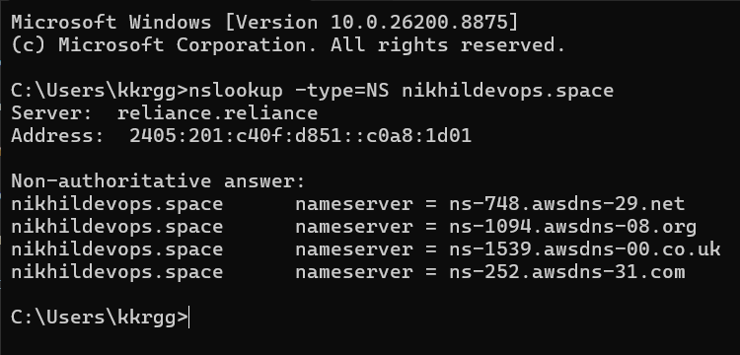

Part 4: Create an Alias Record
Go back to
Route 53 → Hosted Zone
Click
Create record
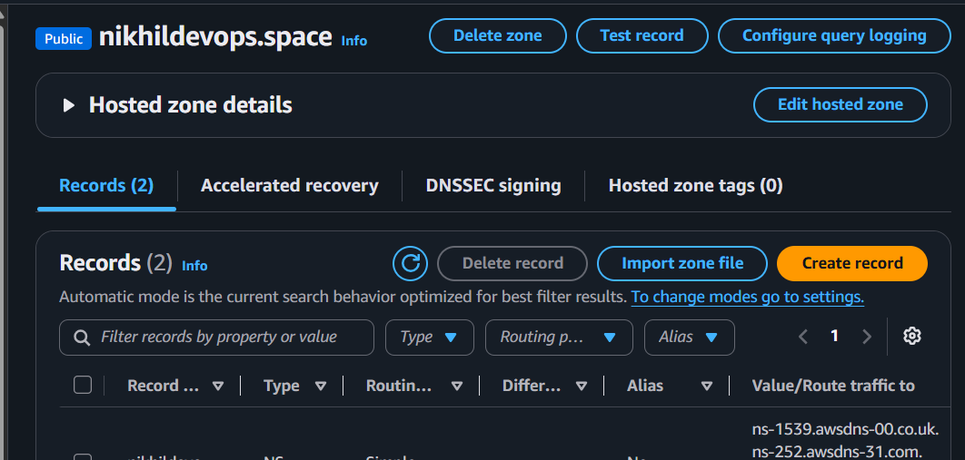
Configure it like this:
Setting | Value
Record name | Leave blank
Record type | A – IPv4 address
Alias | Yes
Route traffic to | Alias to CloudFront distribution
Choose distribution | Select your CloudFront distribution
Click
Create records
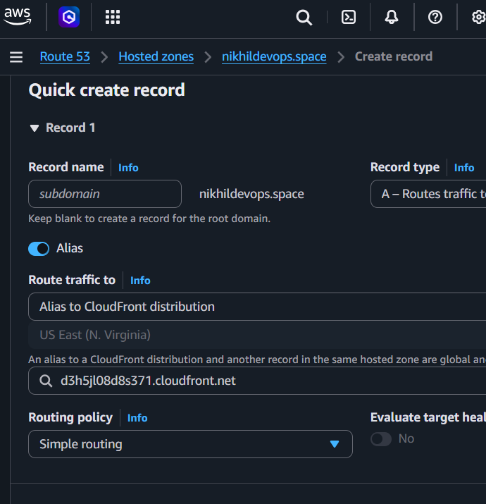
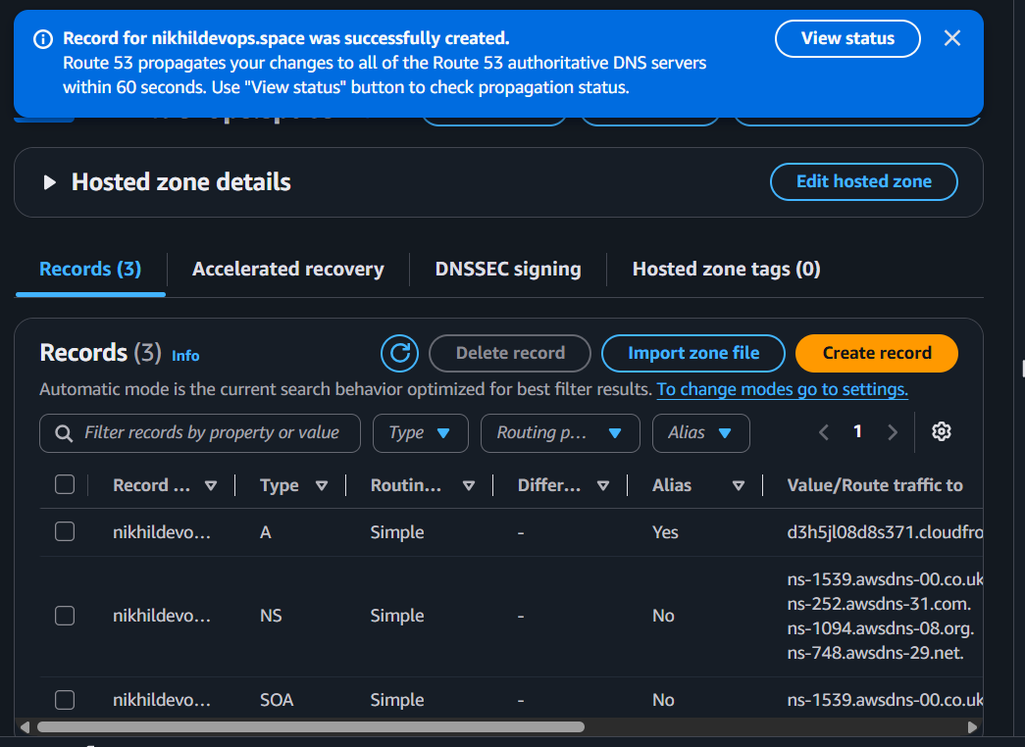

Part 5: Verify
After DNS propagation:
Open
https://nikhildevops.space
Expected result:
- ✅ Website loads successfully.
- ✅ Browser shows a secure lock (HTTPS).
- ✅ Traffic flows through Route 53 → CloudFront → S3.
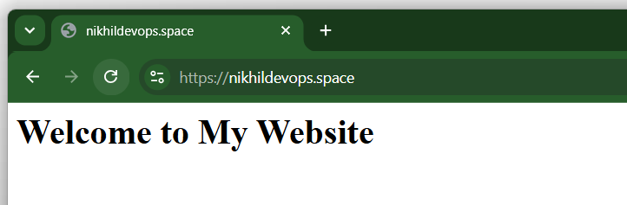

Real-Time Use Case
When a user types:
https://nikhildevops.space
The request follows this path:
User
│
Route 53
│
CloudFront
│
S3 Bucket
Route 53 resolves the domain, CloudFront serves cached content from the nearest edge location (or fetches it from S3 if needed), and the user gets the website over HTTPS.

Validation Checklist
- ✅ Public Hosted Zone created.
- ✅ GoDaddy nameservers updated to Route 53 nameservers.
- ✅ Alias A record created.
- ✅ Alias target is the CloudFront distribution.
- ✅ https://nikhildevops.space opens successfully.

Task 6: Update the index.html in the S3 bucket and ensure the updated file is accessible using the domain name.
Objective
Update the existing website content in the S3 bucket and verify that the changes are visible through your custom domain (https://nikhildevops.space).

Step 1: Update index.html

Option A: Edit in the AWS Console
- Open Amazon S3.
- Open your website bucket.
- Select index.html.
- Click Download.
- Edit it using Notepad or VS Code.
Example:
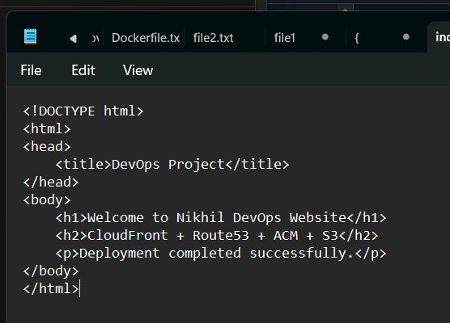
- Save the file.

Step 2: Upload the Updated File
- Go back to your S3 bucket.
- Click Upload.
- Select the updated index.html.
- Since the file already exists, AWS will ask if you want to replace it.
- Choose Replace.
- Click Upload.
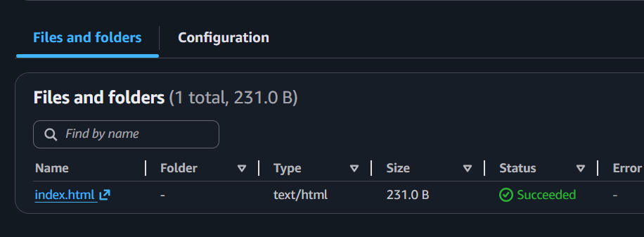

Step 3: Test the Website
Open:
https://nikhildevops.space

If you immediately see the updated page
Our page is successfully ready to access.

Step 4: If You Still See the Old Page
This happens because CloudFront caches content.
You'll need to create a CloudFront Invalidation.

Step 5: Create a CloudFront Invalidation
- Open CloudFront.
- Select your distribution.
- Go to the Invalidations tab.
- Click Create invalidation.
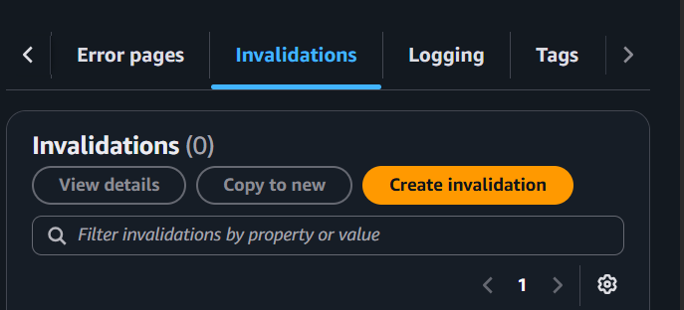
For the path, enter:
/index.html
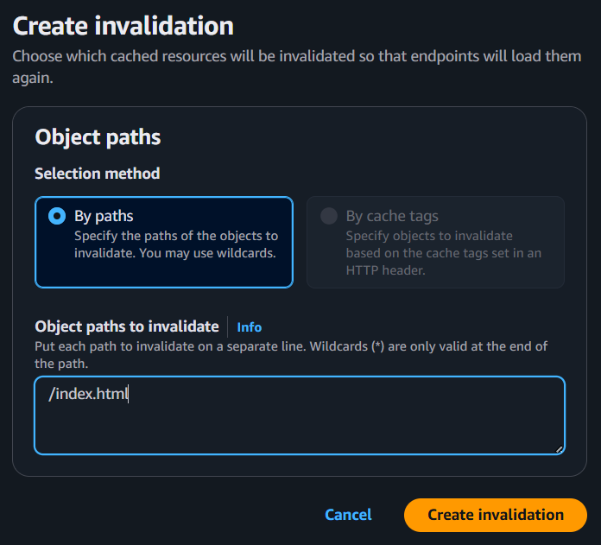
- Click Create invalidation.
Wait until the invalidation status changes to Completed (usually 1–5 minutes).

Step 6: Refresh the Browser
Press:
Ctrl + Shift + R
or
Ctrl + F5
Then visit:
https://nikhildevops.space
You should now see the updated content.
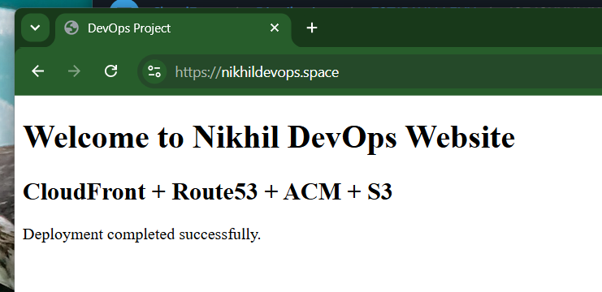

Validation Checklist
- ✅ Updated index.html uploaded to S3.
- ✅ Website accessible at https://nikhildevops.space.
- ✅ Changes visible through the custom domain.
- ✅ CloudFront invalidation completed

